

Making the Templates:

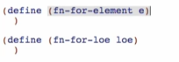

Compound data with the type produced (return values) for the Element template



But reference rule says to wrap the selectors that produce non-primitive types (ListOfElement) in the appropriate function

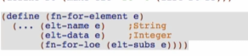

One of two cases with the type produced (return values) for the ListOfElement template

 -> 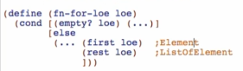

* 1st case – atomic distinct empty



* 2nd case – compound cons

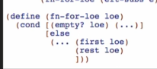

Replacing the type comments with the templates

Element

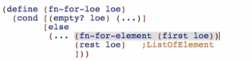

ListOfElement (self-reference)

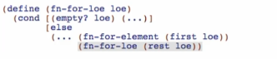

Note: Write templates for mutually referential data types together

Overview:

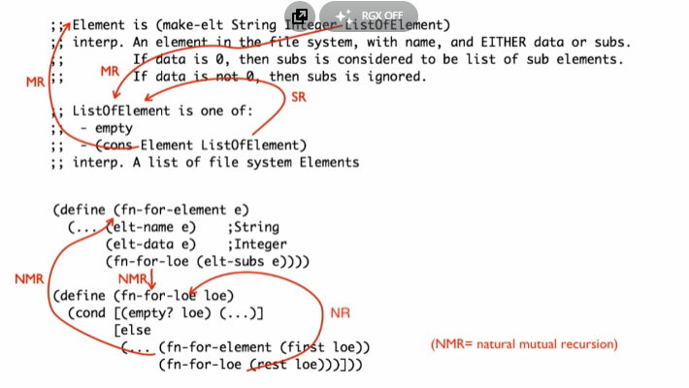

Note: on correspondence, try to make natural recursion as last

Arrow Labels

#1 – NH – Natural Helpers

#2 – NMR – Natural Mutual Recursions

#3 – NR – Natural Recursions